**Important Links**

<https://circuitdigest.com/microcontroller-projects/using-classic-bluetooth-in-esp32-and-toogle-an-led>

**Github**

<https://github.com/espressif/arduino-esp32>

<https://github.com/espressif/arduino-esp32/blob/master/docs/arduino-ide/boards_manager.md>

<https://github.com/esp8266/Arduino>

**ESP32 IDF**

<https://github.com/JoaoLopesF/Esp-Mobile-Apps-Esp32>

**Board Manager URL**

<https://dl.espressif.com/dl/package_esp32_index.json>

<https://dl.espressif.com/dl/package_esp32_dev_index.json>

**Backup**

https://arduino.esp8266.com/stable/package_esp8266com_index.json

**Update Tools in Arduino**

Go into tools, Board Manager, ESP32

**Install:** esp32 by Expressif Systems

**Backup**

Do the same with the esp8266 just in case

**Install:** esp8266 by ESP8266 Community

**Git GUI**

Must follow installation for git gui

<https://github.com/espressif/arduino-esp32/blob/master/docs/arduino-ide/windows.md>

**Using the Development Board**

Go to Arduino IDE > Tools > Board > ***change to the appropriate board***

**YouTube Video Examples**

<https://www.youtube.com/watch?v=NZi7ykalZhc&t=171s>

<https://www.youtube.com/watch?v=5CkGpAai_aI>

<https://www.youtube.com/watch?v=fxvoNpiqipQ>

<https://www.youtube.com/watch?v=AuiWwJZQEec>

<https://www.youtube.com/watch?v=g0pSfyXOXj8>

**Starting Guide for ESP32**

<https://www.youtube.com/watch?v=qbETf0c3jZM>

**Important Guides for BLE**

<https://www.instructables.com/id/ESP32-BLE-Android-App-Arduino-IDE-AWESOME/>

**Sending Multiple Values**

A lot of people have asked this question: "how do I send multiple values to and from the ESP32 and app?" That's a good question, and luckily it's not hard at all! The easiest way I've found is to simply send the values in comma-separated variable (CSV) format. For example, if you're measuring temperature and humidity and you measured 21 *C and 55% humidity and want to send it to the app, simply program the ESP32 to send "21,55" and the app can parse it easily.

<https://github.com/kakopappa/bluetooth_android_esp32_example>

<https://www.hackster.io/botletics/esp32-ble-android-arduino-ide-awesome-81c67d>

**some information about reading data from link down below**

<https://randomnerdtutorials.com/esp32-bluetooth-low-energy-ble-arduino-ide/>

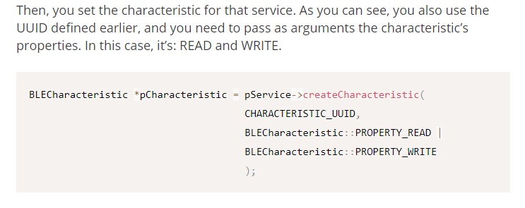

<https://stackoverflow.com/questions/32209957/received-string-data-from-android-apps-blutooh-bluetooth-terminal-to-arduino-u>

<https://esp32.com/viewtopic.php?t=5294>

**Sending/Receiving Data Bluetooth**

<https://www.youtube.com/watch?v=Fz_GT7VGGaQ>

**GATT (Generic Attribute Profile) Read**

<https://github.com/nkolban/esp32-snippets/issues/486>

**Server and Client**

<https://esp32.com/viewtopic.php?t=4181>

**Watch Videos from Kolban Technical Tutorials**

<https://www.youtube.com/channel/UChKn_BlaVrMrhEquPNI6HuQ/playlists>

**ESP32 BLE Arduino by Neil Kolban, Dariusz Krempa**

<https://platformio.org/lib/show/1841/ESP32%20BLE%20Arduino>

**SPI Full Duplex**

<https://docs.espressif.com/projects/esp-idf/en/latest/api-reference/peripherals/spi_master.html>

**Arduino Forum – send data from ESP32 to Android**

Smartphone makes http request to ESP, sends POST data with it, gets data back in the response.

<https://forum.arduino.cc/index.php?topic=525369.0>

**ESP32 Bluetooth SPP bidirectional communication (send and receive)**

<https://esp32.com/viewtopic.php?t=5294>

**Install Eclipse for ESP32**

<https://www.youtube.com/watch?v=bYh2w0HzS7s>

**ESP32 Serial Bluetooth**

<https://techtutorialsx.com/2018/12/09/esp32-arduino-serial-over-bluetooth-client-connection-event/>

**Wi-Fi**

<https://www.youtube.com/watch?v=ROeT-gyYZfw>

<https://www.youtube.com/watch?v=VXsKEVcwzpg>

<https://www.youtube.com/watch?v=m2fEXhl70OY>

**Arduino Time**

<https://www.youtube.com/watch?v=Jwdoah5Fg5g>

**Serial Communication**

<https://www.youtube.com/watch?v=IS7kpna9-sg>

<https://www.youtube.com/watch?v=-6Nb5kL43GY>

<https://www.youtube.com/watch?v=ArzJIAbwiDw>

**Powered by Arduino**

<https://www.youtube.com/watch?v=BfUtpScdQ9Y>

**Sensor**

<https://mybtechprojects.tech/serial-communication-between-nodemcu-and-arduino/>

<https://learn.adafruit.com/force-sensitive-resistor-fsr/using-an-fsr>

**Proximity and Firebase Child Node**

<https://www.youtube.com/watch?v=q3ysxwNpjz0>

**Simple Edition**

<https://randomnerdtutorials.com/complete-guide-for-ultrasonic-sensor-hc-sr04/>

**Eagle Library for ESP8266**

<https://github.com/suhail-jr/ESP8266-12E-Module-Library-For-Eagle>

**Timestamp**

<https://circuits4you.com/2018/01/02/esp8266-nodemcu-ntp-time-clock/>

<https://lastminuteengineers.com/esp8266-ntp-server-date-time-tutorial/>